Day 3 Assignment 1 :

Question 1 :

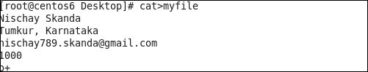

Question 2 :



Question 3 :

